This problem is simply the theorem 3.10 of Higher Geometry – class 9-10.

[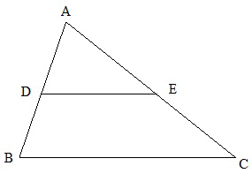](http://3.bp.blogspot.com/-0hWbgVZbaV0/UKeufugZR8I/AAAAAAAAAEk/gLDurIyND40/s1600/a.png)

Problem Statement :   
    You are given **AB**, **AC** and **BC**. **DE** is parallel to **BC**. You are also given the area ratio between **ADE** and **BDEC**. You have to find the value of **AD**.   
  
Let ADE / BDEC = x/y .  
So ADE / ABC = x/(x+y)  
From the theorem,we know that,

ADE / ABC = DE^2 / BC^2  
or, sqrt (ADE / ABC) = DE/BC  
or, sqrt (x/(x+y)) = DE/BC  
or, r = DE/BC where r = sqrt(m)/sqrt((m+n))

As ADE and ABC are congruent triangle, so

AD/AB = DE /BC  
or, AD = DE/BC* AB  
or, AD = r * AB

Thus, the value of AD can be found simply by using the above formula.